Week 10 Final Capstone Project: Production-Grade AI Newsletter System
- Due No due date
- Points 40
- Submitting a website url or a file upload

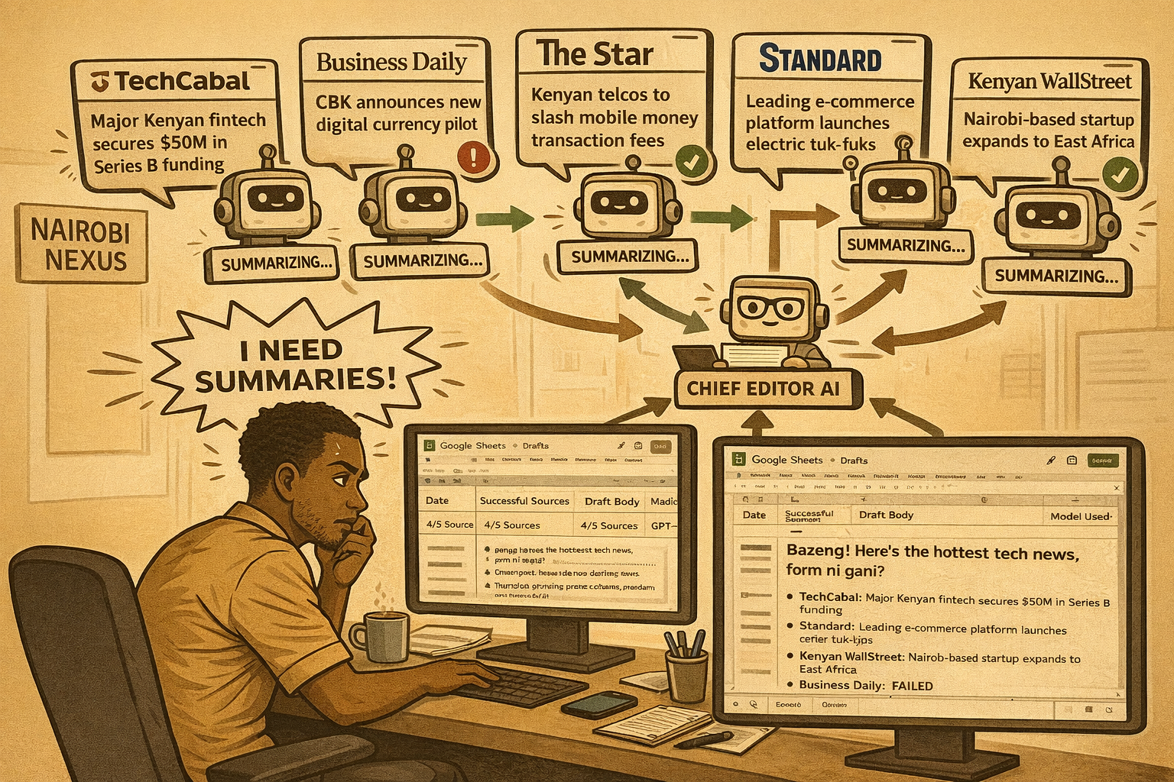

Background
Kamau, the Content Lead at Nairobi Nexus, was impressed by the automated weekly newsletter system you built earlier in the course. For several weeks, it worked well enough to generate a witty, AI-written newsletter every Friday.
However, as the newsletter’s audience has grown, so have the stakes.
- Some weeks, one or two news sources fail silently.
- Occasionally, the AI outputs malformed text that breaks downstream steps.
- Once, a model timeout caused the entire workflow to fail minutes before the send deadline.
Leadership is now asking how reliable the system really is and whether it can be trusted as a production system, not a demo. Kamau needs you to revisit and upgrade your Week 8 solution so that it behaves like a robust, auditable, production-grade AI system.

The Problem
Your original newsletter workflow works, but it was designed as a functional prototype, not a hardened system. Kamau’s new requirements introduce real-world constraints:
- The system must continue operating even when parts fail
- AI outputs must be machine-reliable, not just human-readable
- AI models may fail, timeout, or degrade, the workflow must adapt
- Leadership wants clear operational visibility into what happened each week
To solve this, you must refactor and extend your Week 8 capstone using advanced n8n concepts introduced later in the course, specifically:
- Structured AI output enforcement
- Fault-tolerant workflow design
- Model selection with constraints and fallbacks
- Operational logging and governance signals
Your goal is not to add more features, your goal is to make the system measurably more robust, predictable, and explainable.

What You Must Improve (Core Expectations)
You are expected to start from your Week 8 workflow, then enhance it by implementing the following advanced optimization techniques:
1. Structured AI Output & JSON Reliability
Your AI agents must:
- Output strict, predictable JSON (not free-text)
- Validate or guard against malformed AI responses
- Ensure downstream nodes only receive clean, expected data structures
The system should never “guess” what the AI meant.
2. Fault Tolerance & Resilient Design
Your workflow must:
- Continue executing when individual sources or agents fail
- Isolate failures to specific branches
- Avoid full-workflow failure due to a single error
- Clearly differentiate between partial success and total failure
A production system degrades gracefully, it does not collapse.
3. Model Selection, Constraints & Fallbacks
You must demonstrate:
- Intentional primary model selection for quality
- Clearly defined output constraints (length, format, tone)
- A fallback strategy when the primary model fails (timeouts, errors, quota limits)
- Evidence that fallback paths are tested or logically sound
The workflow should decide, not hope.
4. Operational Logging & Governance Signals
Your system must record:
- Which sources succeeded or failed
- How many inputs were used in the final newsletter
- Which AI model ultimately generated the output
- When the workflow ran and what version of logic was applied
Logs may live in Google Sheets, Databases, or other structured storage nodes. If someone asks, “What happened last Friday?”, your system should answer.

Final Deliverable: Live Presentation
Instead of a traditional submission-only assessment, your final evaluation will include a presentation.
Presentation Format
- Total time: 10 minutes per student
- 7 minutes: Presentation
- 3 minutes: Q&A
What You Must Present
You should clearly explain:
- Your original Week 8 design
- What worked, what assumptions it made, and the weaknesses you identified (Where could it fail? Where was it unreliable or opaque?)
- The upgrades you implemented
- How you enforced structured AI outputs
- How you improved fault tolerance
- How model fallbacks work
- How logging & governance were added
- Why your new solution is more robust (Not just what you built, but why it’s better)
Live demos are optional but encouraged.

Grading Criteria (New & Advanced Focus)
You will now be assessed primarily on system quality, not just correctness:
- Structured AI Output & JSON Reliability
- Fault Tolerance & Resilient Design
- Model Selection, Constraints & Fallbacks
- Operational Logging & Governance Signals
This final capstone evaluates whether you can design production-grade AI workflows, not just working automations.

Closing Note
“Anyone can automate a happy path. This project tests whether you can design for failure, uncertainty, and scale.”

Rubric
Week 10 Final Capstone Rubric
Week 10 Final Capstone Rubric
Criteria | Ratings | Pts
This criterion is linked to a learning outcome Structured AI Output & JSON Reliability | 10 Pts Full marks All AI agents output strict, validated JSON. Workflow includes safeguards (schema checks, parsing validation, defensive logic) that prevent malformed AI output from breaking downstream nodes.  5 Pts Average Marks AI outputs are intended to be structured but rely entirely on prompt discipline. Malformed responses could break downstream steps.  0 Pts No marks AI outputs are unstructured or inconsistent, making the workflow fragile or manual. | 10 pts
This criterion is linked to a learning outcome Fault Tolerance & Resilient Design | 10 Pts Full marks Workflow degrades gracefully. Failures are isolated to branches, partial success is handled intentionally, and the workflow completes execution despite multiple failure scenarios.  5 Pts Average Marks Some fault tolerance exists, but failures can cascade or results lack clarity about what succeeded vs failed.  0 Pts No marks Workflow fails hard on errors or behaves unpredictably when issues occur. | 10 pts
This criterion is linked to a learning outcome Model Selection, Constraints & Fallbacks | 10 Pts Full marks Clear primary vs fallback model strategy. Output constraints are explicit and enforced. Error-triggered routing is deliberate and justified.  5 Pts Average Marks Multiple models used but without clear reasoning or reliable fallback execution. Constraints exist but are weakly enforced.  0 Pts No marks Single-model dependency with no fallback or constraint strategy. | 10 pts
This criterion is linked to a learning outcome Operational Logging & Governance Signals | 10 Pts Full marks Workflow logs actionable operational data: successful vs failed sources, model used, execution date/run, and output status. System is auditable after execution.  5 Pts Average Marks Logging exists but is incomplete or shallow (e.g., only final output stored without context).  0 Pts No marks No meaningful logging or governance visibility. | 10 pts
Total points: 40

